**Supplementary Information**

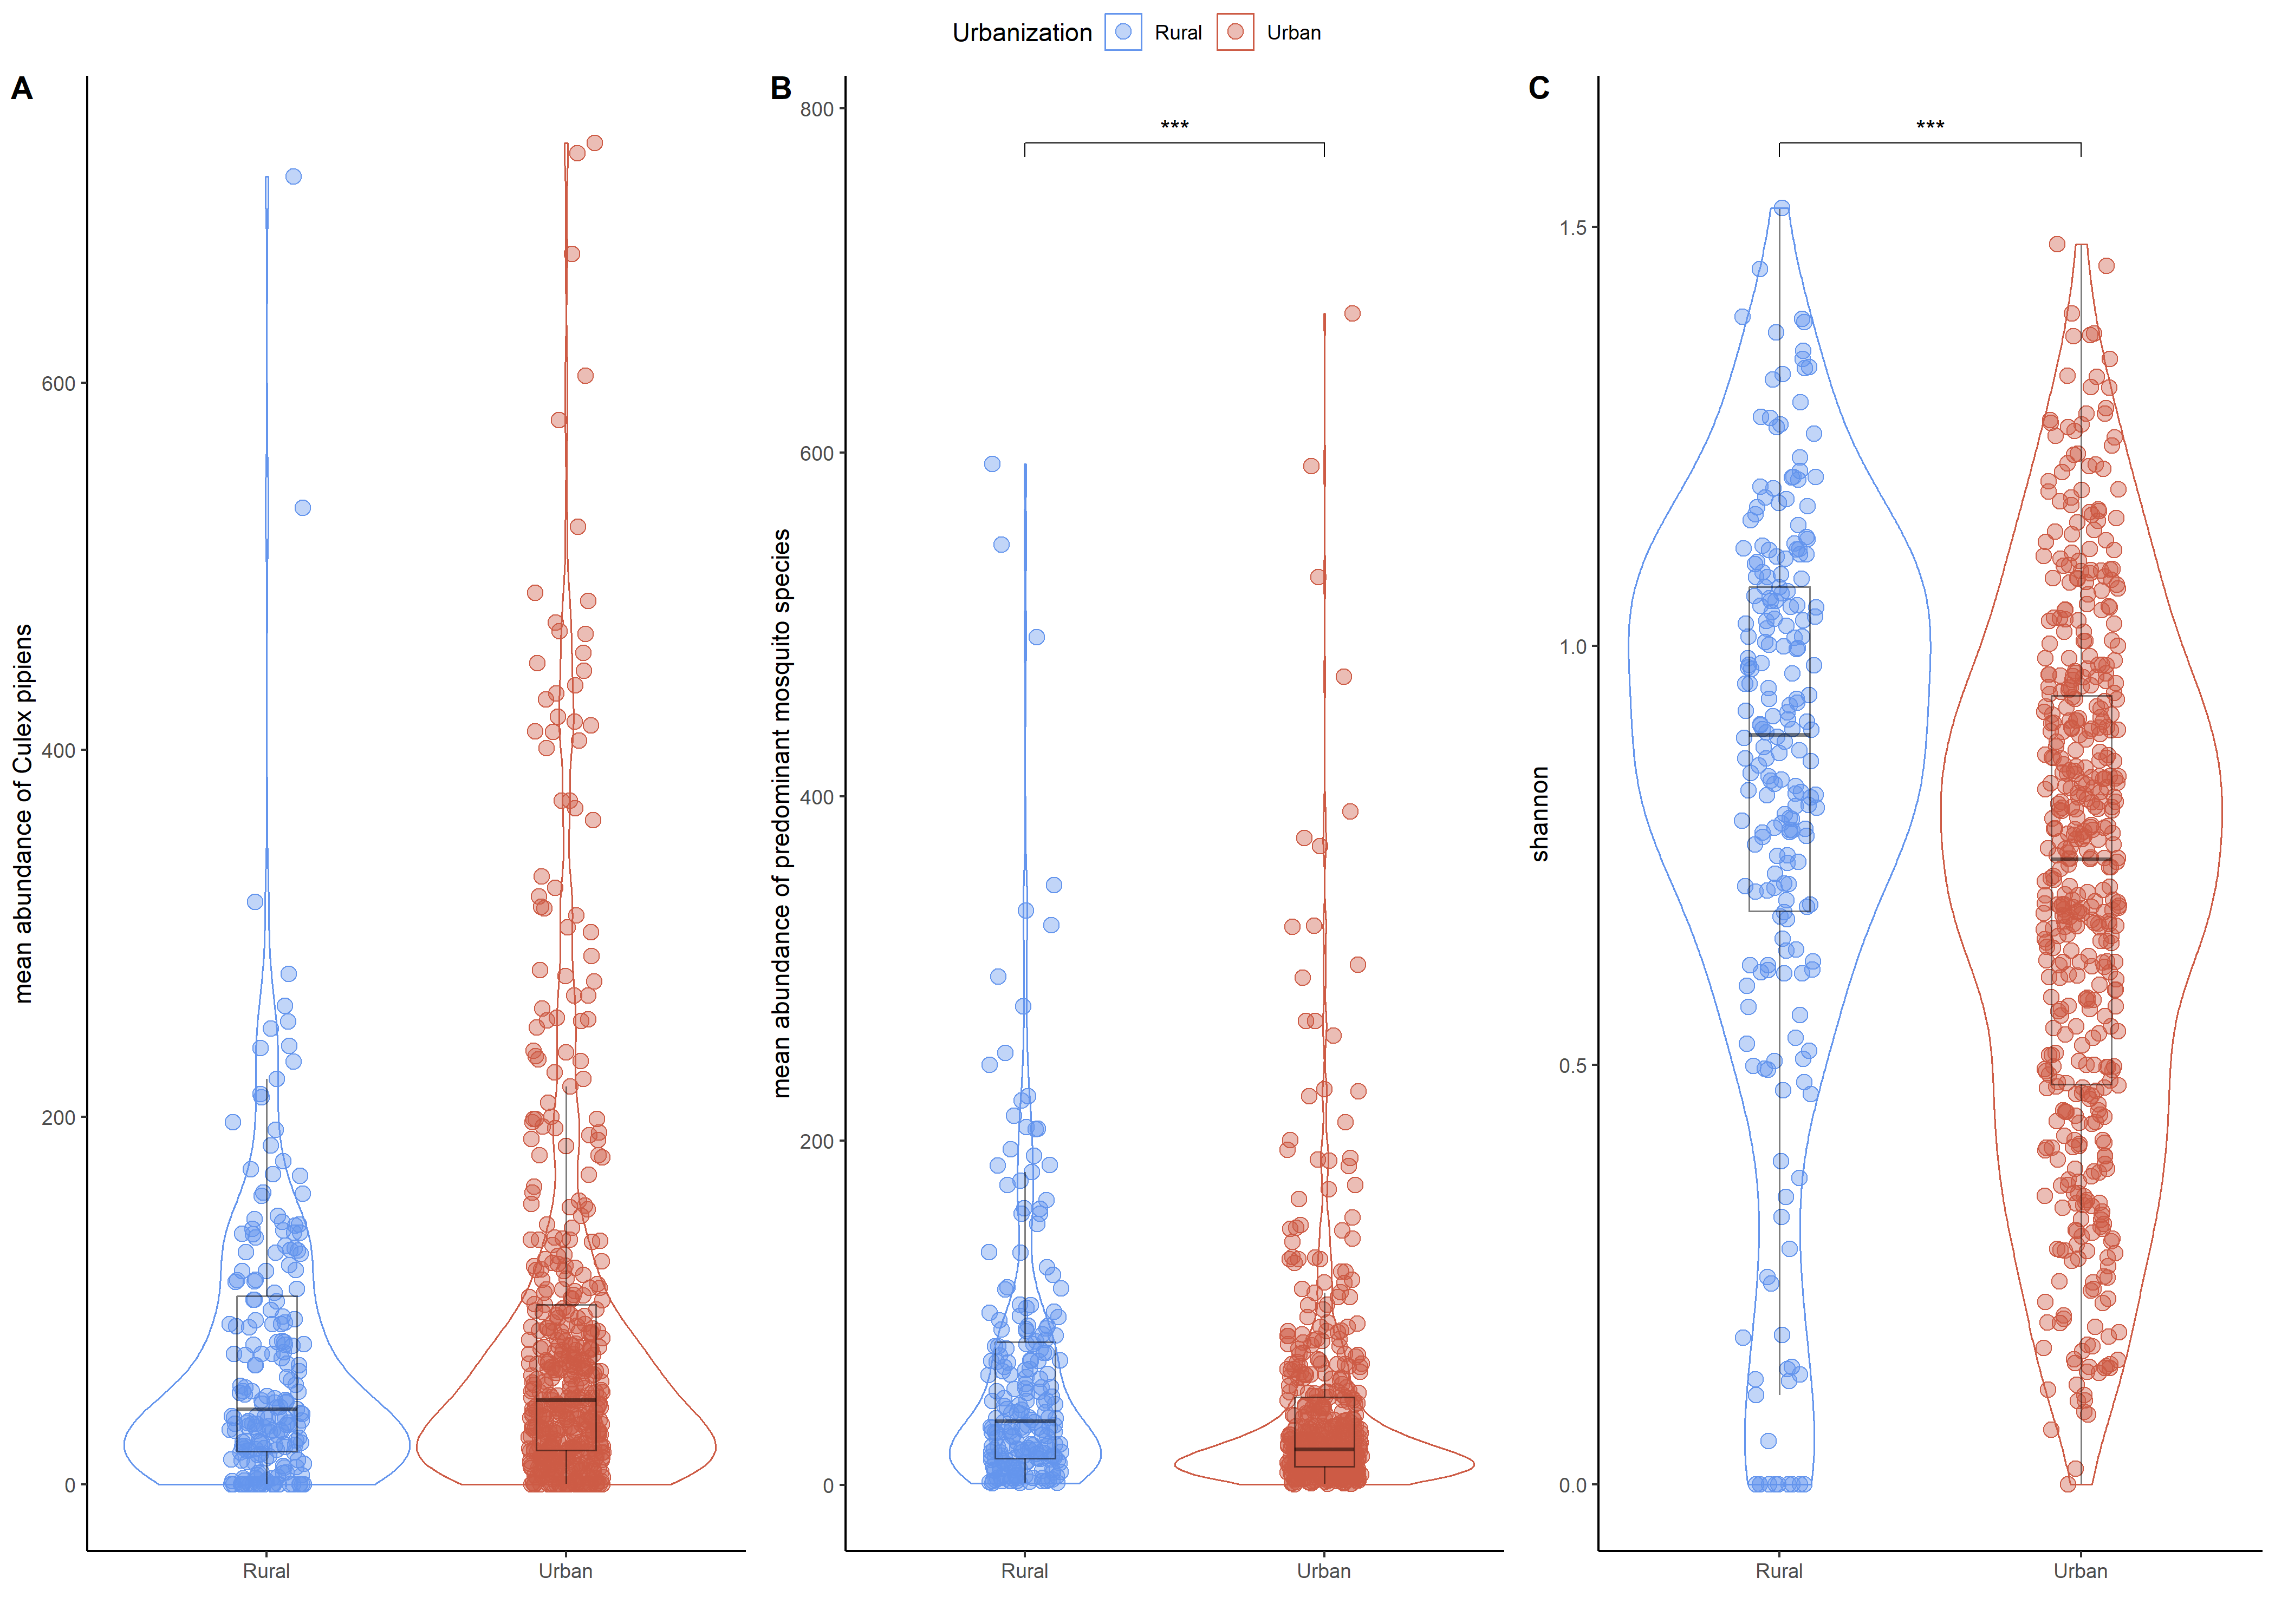

**Figure S1.** Distribution of mosquitoes between urban and rural habitats. Boxplots showing (A) the average abundance of *Culex pipiens* by site, month and year according to the level of urbanization of the habitat. Boxplots showing (B) the average abundance and (C) the composition of mosquito communities by site, month and year according to the level of urbanization of the habitat. The mosquito communities studied are composed of the predominant species in the dataset (*Culex pipiens*, *Culex modestus*, *Aedes vexans*, *Aedes detritus*, *Ochlerotatus caspius*, *Anopheles hyrcanus*). The sites selected here are those for which we had mosquito trapping data available (13 sites out of 18). Blue dots represent urban sites, while red dots represent rural sites.

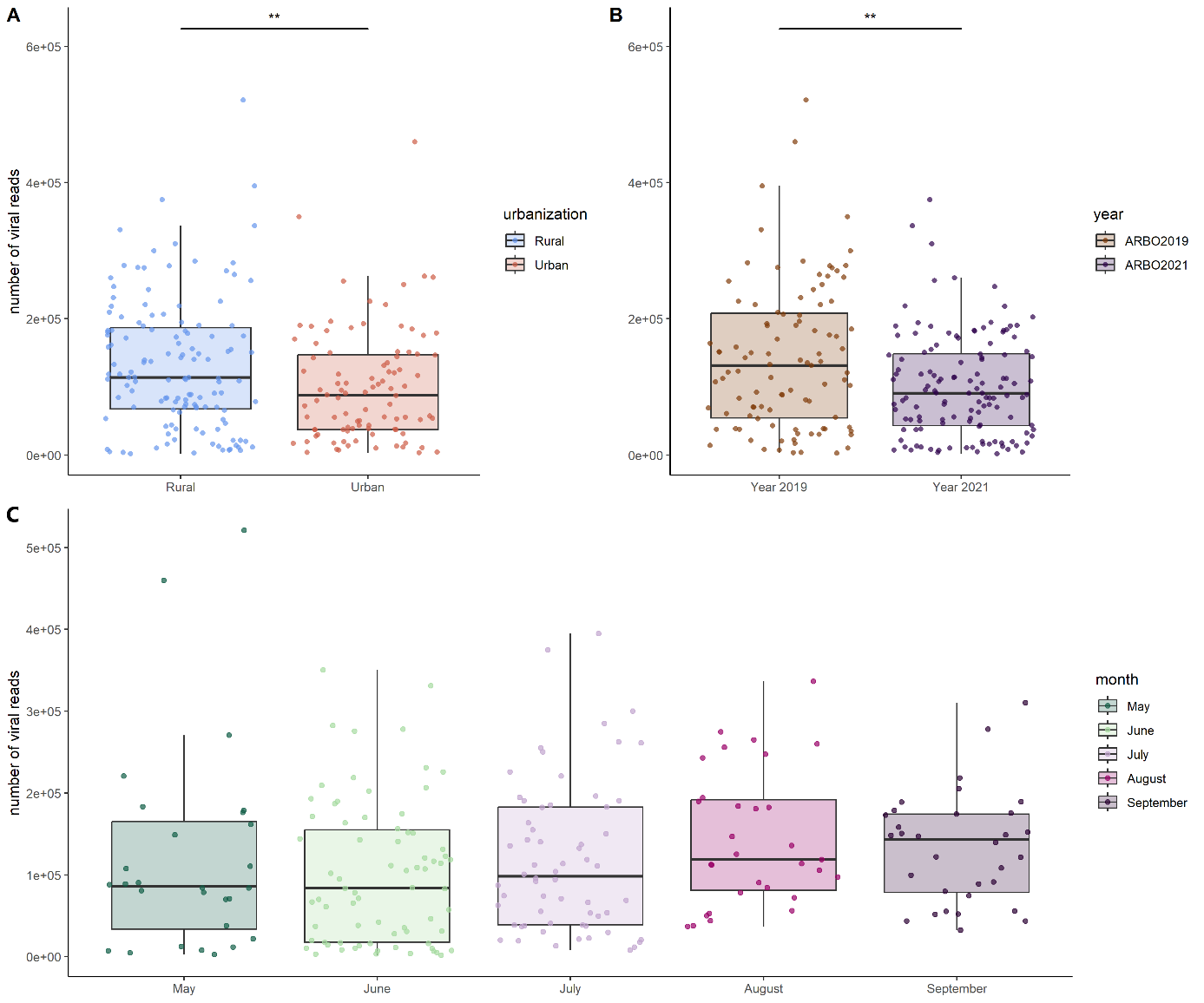

**Figure S2.** Distribution of viral reads by (A) urbanization level, (B) year and (C) months. The bar above the boxplots for each panel represents the value and degree of significance between the different groups, according to the wilcoxon test values. Significance codes: 0 '***', 0.001 '**', 0.01 '*', 0.05 '.', 0.1 ''.

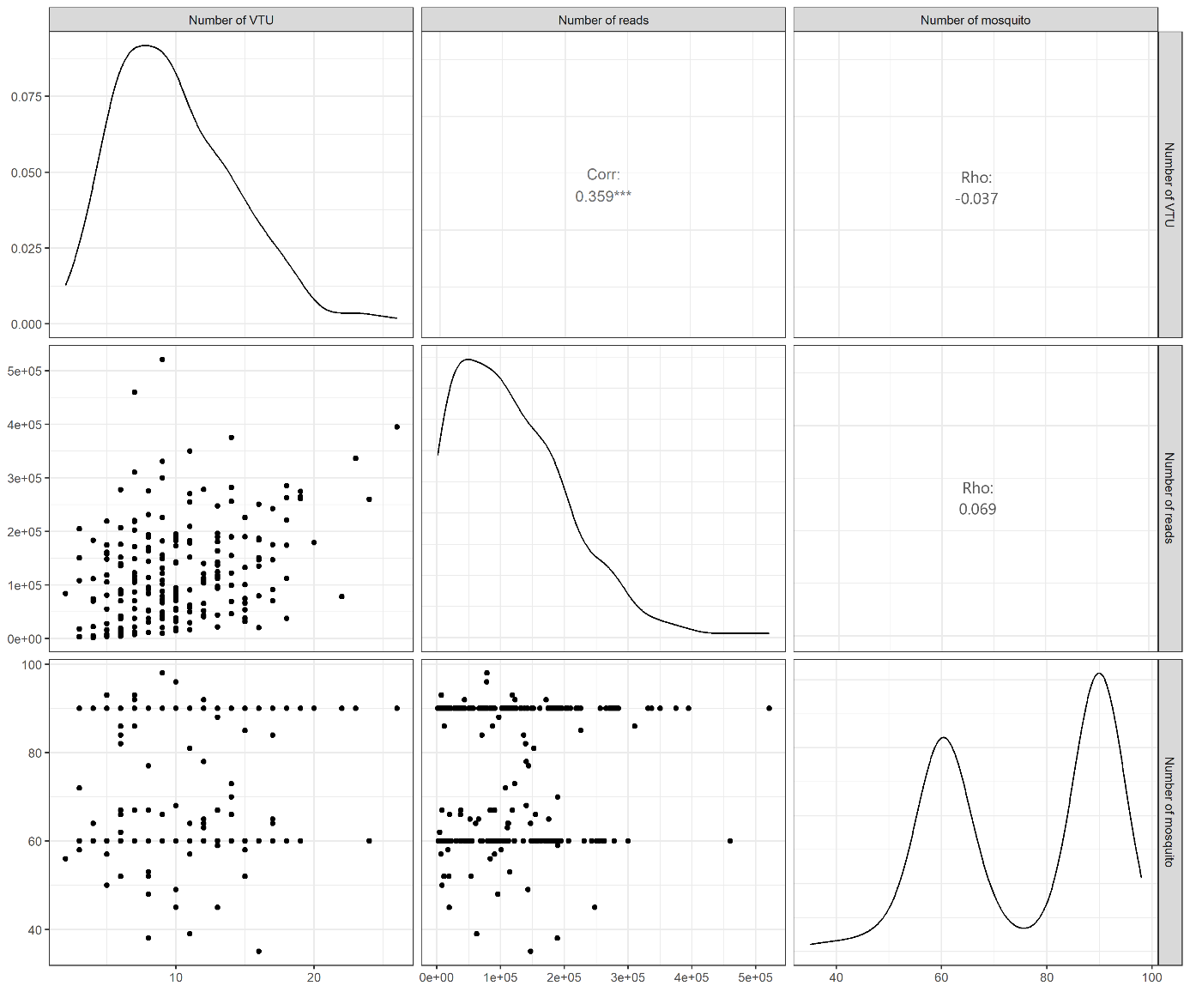

**Figure S3.** Plot matrix showing graphs and correlation values between the number of VTUs, the number of viral reads and the number of mosquitoes in the pool. Each of these variables is compared two by two in the graph, and the correlation results are found at the intersection between a given pair of variables.

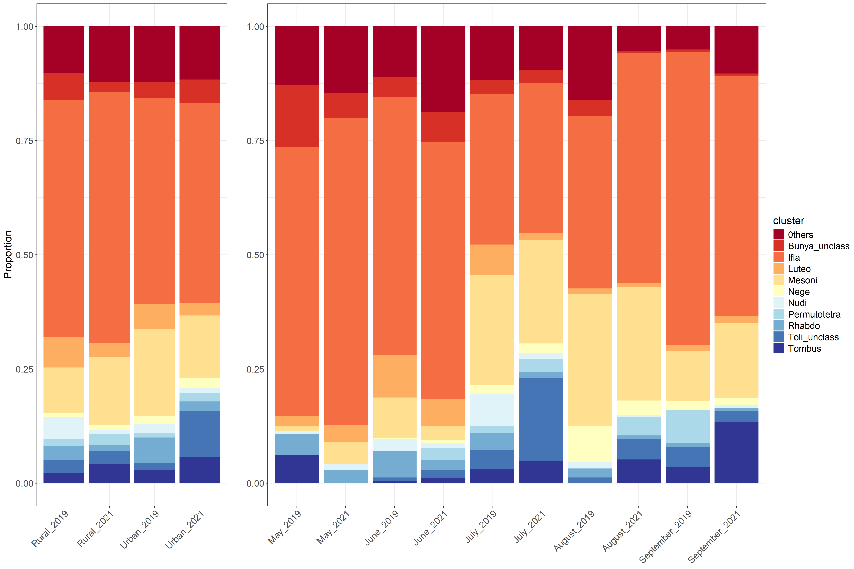

**Figure S4.** The bar plots represent the relative abundance of the ten most abundant clusters on average in our dataset, by level of urbanization and year (left bar plot) and by month and year (right bar plot). The relative abundance of other clusters is shown in dark red in both bar plots (classified as "Others").

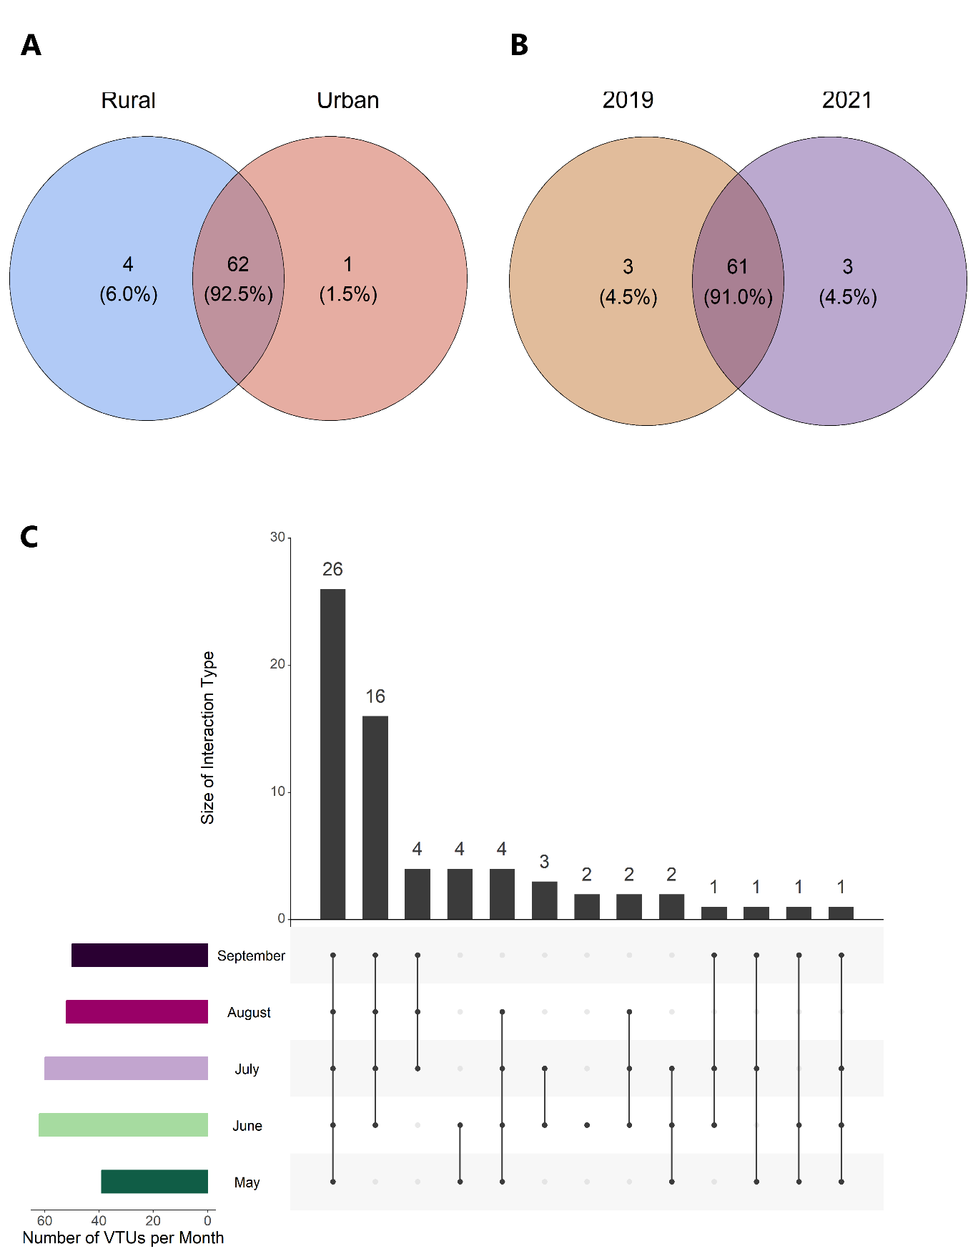

**Figure S5.** Presence-absence of viral taxonomic units (VTUs) among libraries and different ecological factors. The presence of VTUs is divided into the following categories: Venn diagram separated by (A) urbanisation and (B) year. The numbers in brackets represent the proportion of each group in relation to the total number of MPVs. (C) An upset diagram was used to represent the presence of VTUs in each month. The black vertical bars represent the number of VTUs present in exactly five, four, three, two or one month. The number above each bar corresponds to the number of VTUs in each category. The dots directly below the black bars correspond to the month(s) represented in that category. The coloured horizontal bars to the left of the list of months indicate the number of VTUs for each month.